**Time to Surgery and Breast Cancer Survival in the United States**

*Richard J. Bleicher, MD; Karen Ruth, MS; Elin R. Sigurdson, MD, PhD; J. Robert Beck, MD; Eric Ross, PhD; Yu-NingWong, MD, MPH; Sameer A. Patel, MD; Marcia Boraas, MD; Eric I. Chang, MD; Neal S. Topham, MD; Brian L. Egleston, PhD*

JAMA Oncol. 2016;2(3):330-339. doi:10.1001/jamaoncol.2015.4508

94 544 SEER-Medicare patients: Mean (SD) age was 75.2 (6.2) years. SEER-Medicare patients were diagnosed between 1992 and 2009 with invasive, noninflammatory, nonmetastatic breast cancer.

The increase in mortality in all stages for all patients and from all causes was 9% (HR, 1.09; 95%CI, 1.06-1.13; *P* < .001) for each preoperative interval category* increase (Figure 1A). The TTS was statistically significant with respect to OS in stage I (HR, 1.13; 95%CI, 1.08-1.18; *P* < .001) and stage II disease (HR, 1.06; 95% CI, 1.01-1.11; *P* = .01), but not in stage III (HR, 1.06; 95%CI, 0.97-1.16; *P* = .17). The association with disease-specific mortality was significant for stage I disease (sHR, 1.84; 95%CI, 1.10-3.07; *P* = .02) but not for stage II or stage III.

National Cancer Database

There were 115 790 NCDB patients analyzed. Mean (SD) patient age was 60.3 (13.4) years, and ages ranged from 18 to 90 years.

The added risk of death from all causes for each interval increase* inTTS was 10.0% (HR,1.10;95%CI, 1.07-1.13;*P* < .001) (Figure 1B) for the entire cohort. The TTS was associated with OS for stage I (HR, 1.16; 95%CI, 1.12-1.21; *P* < .001) and stage II disease (HR, 1.09; 95%CI, 1.05-1.13; *P* < .001) but not stage III (HR, 1.01; 95%CI, 0.96-1.07; *P* = .64).

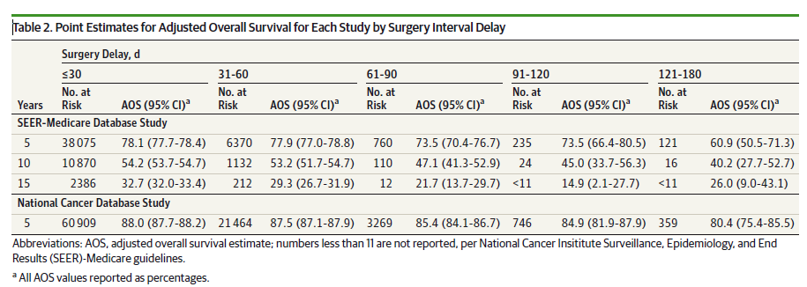

*30 days or less, 31 to 60 days, 61 to 90 days, 91 to 120 days, and 121 to 180 days between diagnosis and surgery.

<https://jamanetwork.com/journals/jamaoncology/fullarticle/2474438>

**Preoperative Delays in the Treatment of DCIS and the Associated Incidence of Invasive Breast Cancer**

*William H. Ward, MD, MS1, Lyudmila DeMora, MS2, Elizabeth Handorf, PhD2, Elin R. Sigurdson, MD, PhD3, Eric A. Ross, PhD, ScM2, John M. Daly, MD3, Allison A. Aggon, DO3, and Richard J. Bleicher, MD3*

Ann Surg Oncol (2020) 27:386–396, https://doi.org/10.1245/s10434-019-07844-4

Ductal carcinoma in situ (DCIS).

The 140,615 patients analyzed overall had a median follow up of 57.7 months, and 47.5% of patients had >60 months of follow-up. Mean (SD) patient age was 58.6 (11.9) years, ranging 18–90.

Five-year OS was 95.8% (95% CI 95.7–96.0%). Following adjustment, greater time to surgery (TTS), with multiple other factors, was independently associated with poorer survival (eTable 2). A total of 39,364 (28.0%) patients had[1 surgery date recorded. A sensitivity analysis (eTable 3) excluding these women from the adjusted analysis found surgical delay significantly associated with OS (HR 1.12; 95% CI 1.09–1.16; P\0.0001). Added risk of death from all causes for each 30-day interval delay increase was 7.4% (HR 1.07; 95% CI 1.05–1.10; P\0.0001) for the entire cohort.

Among those without invasion: the added risk of death from all causes for each 30-day interval increase in delay among the noninvasive cohort was 7.3% (HR 1.07; 95% CI 1.05–1.10; P\0.0001) (eTable 4).

Among the invasive patients: the added risk of death from all causes for each 30-day interval

increase in delay among the invasive cohort was 6.8% (HR 1.07; 95% CI 1.01–1.13; P = 0.0306; eTable 5).

After adjustment, increasing delay to surgery in the entire cohort was an independent predictor of invasion (OR 1.13; 95% CI 1.10–1.15; P\0.001).

<https://link.springer.com/article/10.1245/s10434-019-07844-4>